**Module 2**

***Intelligent Agents***

1. **Introduction to agents**

An agent can be anything that perceives the environment through sensors and acts upon that environment through actuators.

A rational agent could be anything that makes decisions, as a person, firm, machine, or software. It carries out an action with the best outcome after considering past and current percepts

**Human-Agent:** A human agent has eyes, ears, and other organs which work for sensors and hand, legs, and vocal tract work for actuators.

**Robotic Agent:** A robotic agent can have cameras, infrared range finder, NLP for sensors and various motors for actuators.

**Software Agent:** Software agent can have keystrokes, file contents as sensory input and act on those inputs and display output on the screen

1. **Structure of Intelligent Agent**

Behavior of an agent is the action that is performed after any given sequence of percepts. Structure of agents tells about how the insides work. The job of AI is to design the agent program that implements the agent function mapping percepts to actions. We assume this program will run on some sort of computing device with physical sensors and actuators--we call this the architecture:

***agent = architecture + program***

The program we choose has to be one that is appropriate for the architecture. The architecture makes the precepts from the sensors available to the program, runs the program, and feeds the program's action choices to the actuators as they are generated. the main three terms involved in the structure of an AI agent:

**Architecture:** Architecture is machinery that an AI agent executes on.

**Agent Function:** Agent function is used to map a percept to an action.

**Agent program:** Agent program is an implementation of agent function. An agent program executes on the physical architecture to produce function f.

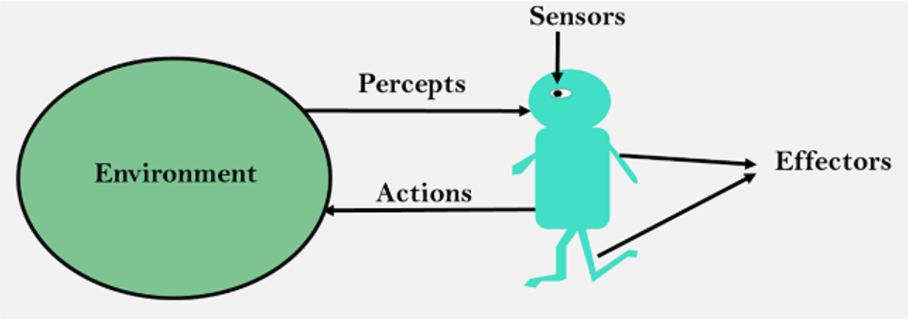

1. **Characteristics of Intelligent Agents**

* **Situatedness**The agent receives some form of sensory input from its environment, and it performs some action that changes its environment in some way. Examples of environments: the physical world and the Internet.
* **Autonomy**  
  The agent can act without direct intervention by humans or other agents and that it has control over its own actions and internal state.
* **Adaptivity**  
  The agent is capable of (1) reacting flexibly to changes in its environment; (2) taking goal-directed initiative (i.e., is proactive), when appropriate; and (3) learning from its own experience, its environment, and interactions with others.
* **Sociability**  
  The agent is capable of interacting in a peer-to-peer manner with other agents or humans.

1. **Types of Agents:**
2. **Simple Reflex**
3. The Simple reflex agents are the simplest agents.
4. These agents take decisions on the basis of the current percepts and ignore the rest of the percept history.
5. The Simple reflex agent does not consider any part of history during their decision and action process.
6. These agents only succeed in the fully observable environment.
7. The Simple reflex agent works on Condition-action rule, which means it maps the current state to action. Such as a Room Cleaner agent, it works only if there is dirt in the room.

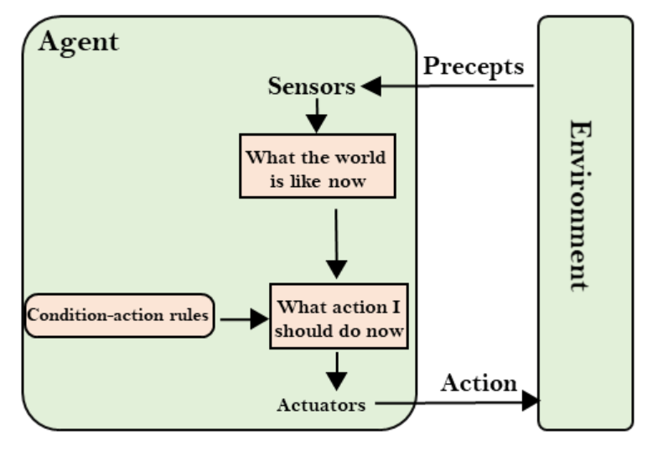

1. **Model Based**

The Model-based agent can work in a partially observable environment, and track the situation.

A model-based agent has two important factors:

* 1. Model: It is knowledge about "how things happen in the world," so it is called a Model-based agent.
  2. Internal State: It is a representation of the current state based on percept history.

These agents have the model, "which is knowledge of the world" and based on the model they perform actions.

Updating the agent state requires information about:

* 1. How the world evolves
  2. How the agent's action affects the world.

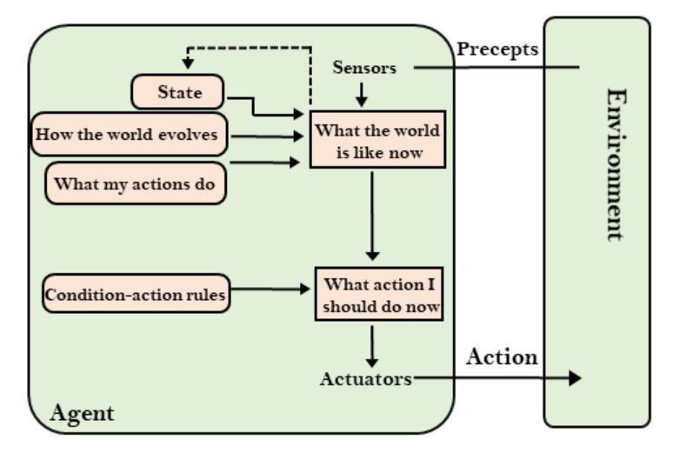

1. **Goal Based**
2. The knowledge of the current state environment is not always sufficient to decide for an agent what to do.
3. The agent needs to know its goal which describes desirable situations.
4. Goal-based agents expand the capabilities of the model-based agent by having the "goal" information.
5. They choose an action, so that they can achieve the goal.
6. These agents may have to consider a long sequence of possible actions before deciding whether the goal is achieved or not. Such considerations of different scenarios are called searching and planning, which makes an agent proactive.

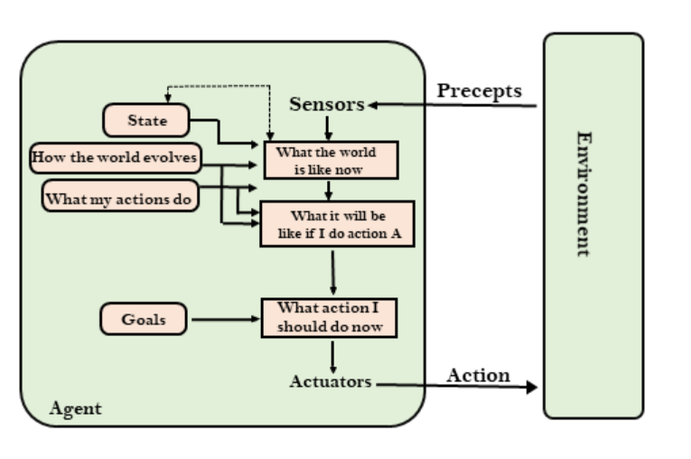

1. **Utility Based Agents**
2. These agents are similar to the goal-based agent but provide an extra component of utility measurement which makes them different by providing a measure of success at a given state.
3. Utility-based agent act based not only goals but also the best way to achieve the goal.
4. The Utility-based agent is useful when there are multiple possible alternatives, and an agent has to choose in order to perform the best action.
5. The utility function maps each state to a real number to check how efficiently each action achieves the goals.

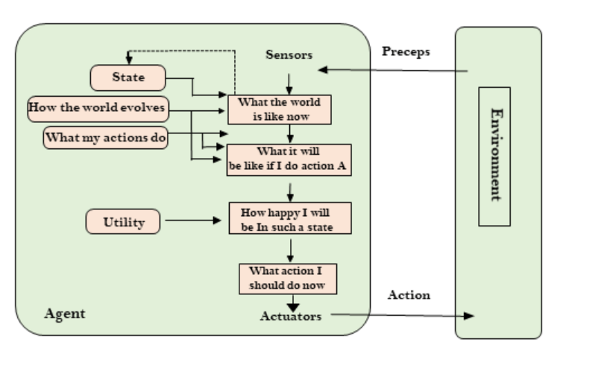

**PEAS-**

There are different types of agents in AI. PEAS System is used to categorize similar agents together. The PEAS system delivers the performance measure with respect to the environment, actuators, and sensors of the respective agent. Most of the highest performing agents are Rational Agents.

PEAS stands for a *Performance measure, Environment, Actuator, Sensor*.

* **Performance Measure**: Performance measure is the unit to define the success of an agent. Performance varies with agents based on their different precepts.
* **Environment**: Environment is the surrounding of an agent at every instant. It keeps changing with time if the agent is set in motion. There are 5 major types of environments:

1. Fully Observable & Partially Observable
2. Episodic & Sequential
3. Static & Dynamic
4. Discrete & Continuous
5. Deterministic & Stochastic

* **Actuator:** An actuator is a part of the agent that delivers the output of action to the environment.
* **Sensor:** Sensors are the receptive parts of an agent that takes in the input for the agent

1. **Environment Types:**
2. **Observable and Semi-observable**
3. When an agent sensor is capable of sensing or accessing the complete state of an agent at each point in time, it is said to be a fully observable environment else it is partially observable.
4. Maintaining a fully observable environment is easy as there is no need to keep track of the history of the surrounding area.
5. An environment is called unobservable when the agent has no sensors in all environments.
6. Examples:

* Chess – the board is fully observable, and so are the opponent’s moves.
* Driving – the environment is partially observable because what’s around the corner is not known

1. **Static and Dynamic**
2. An environment that keeps constantly changing itself when the agent is up with some action is said to be dynamic.

* A roller coaster ride is dynamic as it is set in motion and the environment keeps changing every instant.

1. An idle environment with no change in its state is called a static environment.

* An empty house is static as there’s no change in the surroundings when an agent enters

1. **Deterministic and Stochastic**
2. When a uniqueness in the agent’s current state completely determines the next state of the agent, the environment is said to be deterministic.
3. The stochastic environment is random in nature which is not unique and cannot be completely determined by the agent.
4. Examples:

* Chess – there would be only a few possible moves for a coin at the current state and these moves can be determined.
* Self-Driving Cars- the actions of a self-driving car are not unique, it varies time to time

1. **Single Agent and Multi Agent**
2. An environment consisting of only one agent is said to be a single-agent environment.

* A person left alone in a maze is an example of the single-agent system.

1. An environment involving more than one agent is a multi-agent environment.

* The game of football is multi-agent as it involves 11 players in each team